**The Spaceman Design Outline**

Epsilon is a 2D atmospheric puzzle platformer and need a spaceman player sprite. Think Limbo in space. Lots of puzzles and dangers.

Requests:

* A 2D sprite (separated limbs)
* The white accents in the suit as a separate sheet.

I would like to keep the detail of the spaceman quite ambiguous, retaining the black elements and work on the silhouette. Less is more.

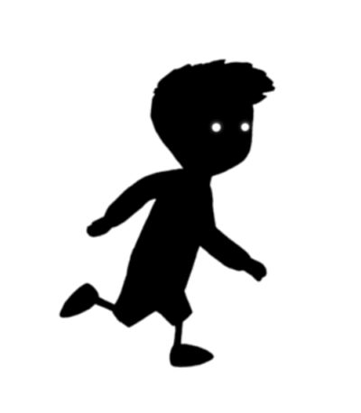

The suit needs to have some basic white accents.

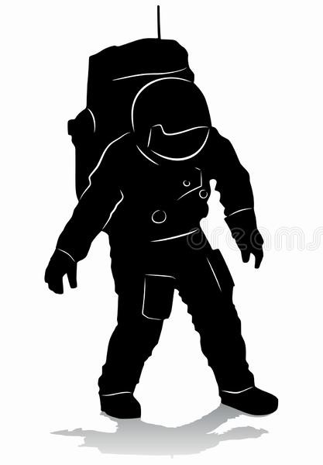

* White accents in the suit

Strip down the side of the arm that will glow and change colour (this might change colour to danger or the status of the suit i.e. health. I like the suits from Tron Legacy. I think an arm strip might work but a whole suit design might look cool. The arm might work best as it’s simpler.

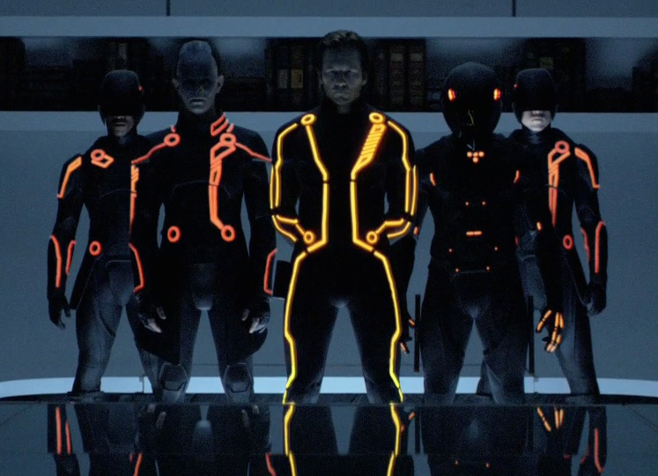

* Sprite limbs need to come in separate parts. The Jetpack not too big.

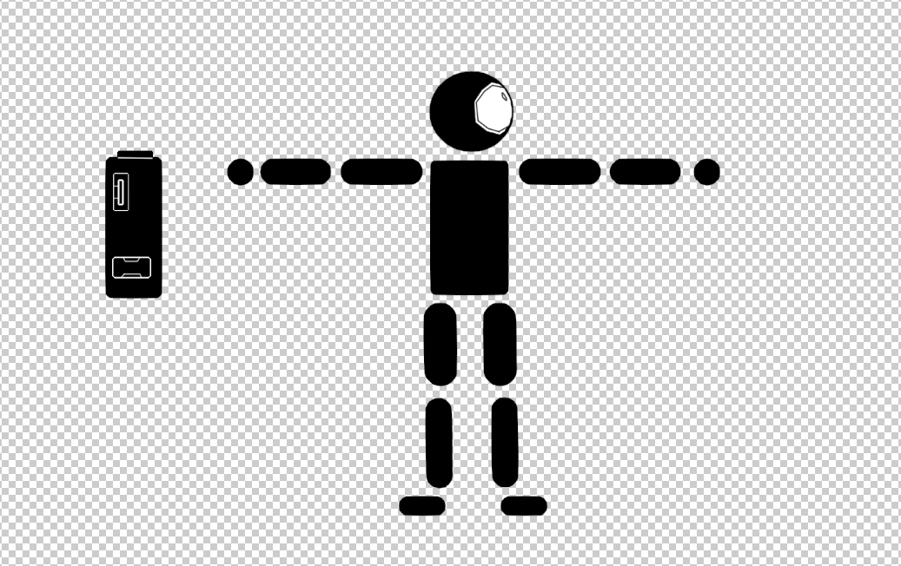

* The side of the helmet to have some sort of light projector.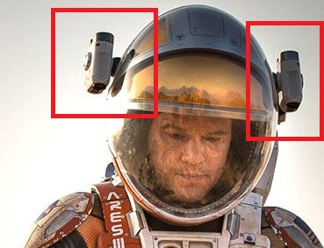
* Overall suit designs

The suit should look somewhat futuristic, but lightweight Should be able to jog/jump in it.

